SOI Toposheets Number Calculator
(QGIS Python Plugin Version 4)
TopoSheet Number Calculator Version 4 is an advanced Python plugin developed for QGIS 4 that automatically calculates and generates map sheet numbers for the Survey of India (SOI) Topographical Maps. The plugin is designed to assist researchers, GIS professionals, planners, surveyors, and students in identifying the correct topographic map sheets corresponding to any spatial dataset within the Indian region.
The plugin computes the boundaries of all relevant map sheets for the extent of the selected input layer and creates a new polygon layer representing the sheet boundaries. Each generated polygon is automatically labelled with its corresponding sheet number, enabling easy visualization and identification of map coverage. This plugin is available for download form QGIS Plugin repository (https://plugins.qgis.org/plugins/TopoNum/#plugin-versions) or it can be directly installed from the QGIS Manage and Install Plugins options under the experimental plugins category.
The plugin supports both:
- Old Series Maps (India and Adjoining Countries Series Maps), and
- New Open Series Maps (OSM) introduced after 2005 based on the Universal Transverse Mercator (UTM) projection system and World Geodetic System (WGS 84 Datum).
The plugin can calculate sheet numbers for all available map scales in both map series. It dynamically generates sheet boundaries and visually distinguishes the sheets that intersect with the input features.
Key Features
- Automatic calculation of Survey of India Toposheet numbers.
- Supports both Old Series Maps and Open Series Maps (OSM).
- Generates polygon boundaries for all relevant map sheets.
- Automatic labelling of generated sheets with map sheet numbers.
- Highlights intersecting sheets using light green fill colour.
- Non-intersecting surrounding sheets are displayed in yellow colour.
- Generated sheet boundary layers are automatically added to the QGIS Layer Panel.
- Supports multiple geometry types:
  - Point layers
  - Line layers
  - Polygon layers
- Compatible with:
  - Geographic Coordinate System (EPSG:4326, WGS 84)
  - Universal Transverse Mercator (UTM) projected coordinate systems
- Efficient handling of layer extents and spatial intersections.
- User-friendly interface suitable for both beginners and advanced GIS users.
Coordinate Reference System Requirements
The plugin primarily works with datasets in the Geographic Coordinate Reference System (CRS) using:
- EPSG:4326 — WGS 84
The updated Version 4 also supports layers having projected coordinates in the Universal Transverse Mercator (UTM) projection system. The plugin automatically processes the layer extent and computes the appropriate map sheets accordingly. The user interface of the plugin is shown in Fig.1.
For accurate results, the spatial extent or coordinate values of the input layers must lie within the geographical region of India.
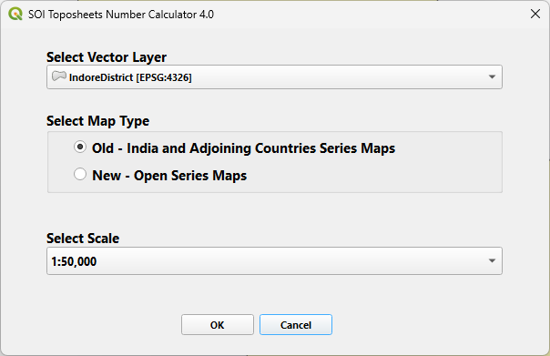
Fig.1 - User Interface of Plugin
Workflow
- Select the desired input layer in QGIS.
- Choose the map series type:
  - Old Series Maps
  - Open Series Maps (OSM)
- Select the required map scale.
- Run the plugin.
- The plugin automatically:
  - Computes the sheet boundaries,
  - Generates sheet polygons,
  - Labels the polygons with sheet numbers,
  - Highlights intersecting sheets,
  - Adds the generated layer to the QGIS project.
Applications
The plugin is highly useful for:
- Topographical map indexing
- GIS-based planning and analysis
- Field survey preparation
- Academic and research work
- Geospatial data organization
- Cartographic applications
- Remote sensing and terrain studies
TopoSheet Number Calculator Version 4 significantly simplifies the otherwise time-consuming process of manually identifying Survey of India topographic sheets and provides an efficient GIS-based solution within the QGIS environment.

